**PREDICTING HOSPITAL READMISSION FOR PATIENTS WITH DIABETICS**

**1 INTRODUCTION:**

**1.1 Overview**

In this prediction we will be predicting whether a diabetic patient will get readmitted into the hospital or not.Here we are seeing some parameters of the patientwhich are the levels of hormones like insulin, metformin, repaglinide,nateglinideand some other parameters which causes diabetics, race, gender, if there was a change in medication and if there was any diabetic medication required by these parameters we can analyze whether the patient will get readmitted or not.

**1.2 Purpose**

To predict whether a diabetic patient will get readmitted or not depending on some specified parameters such as hormonal levels, race, gender and some other parameters and it outputs by yes or no.

**2 LITERATURE SURVEY:**

**2.1 Existing problem**

A diabetic patient should be very careful with the hormonal levels and needs proper medication. If a patient gets medicated once and relaxed without having prior knowledge of whether one needs further medication that is, one will readmit for medication or not may disturbs once normal life also hospital readmission rates for certain conditions are now considered as indicator of hospital quality, and also affect the cost of care adversely.

**2.2 Proposed solution**

This model by taking the inputs from the patients or users predicts the readmission of patients can help hospitals to decrease their readmission rate as well as patients save money.

**3. THEORITICAL ANALYSIS :**

**3.1 Block diagram:**

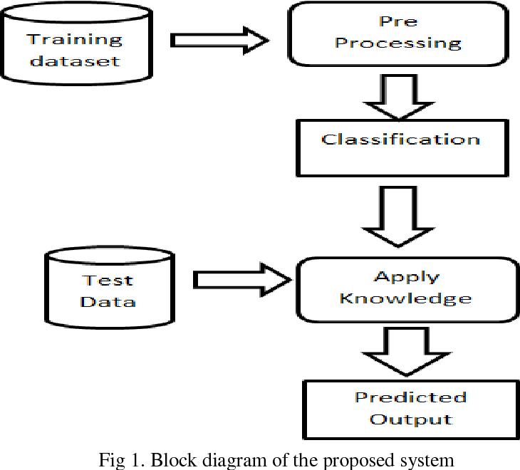

**3.2  Hardware / Software designing :**

* Strategy: matching the problem with the solution.
* Dataset preparation and preprocessing. Data collection. Data visualization. Labeling. Data selection. Data preprocessing. Data transformation.
* Dataset splitting into train data and test data.
* Modeling. Model training. Model evaluation and testing. Improving predictions with ensemble methods.
* Model deployment.
* Webpage designing using Python & HTML.
* Prediction is done through Webpage.

**4. EXPERIMENTAL INVESTIGATIONS**

During our investigation, we found a dataset which we need for our model and depending upon the performance of model we have choosen the best model with good accuracy.

**5. FLOWCHART**

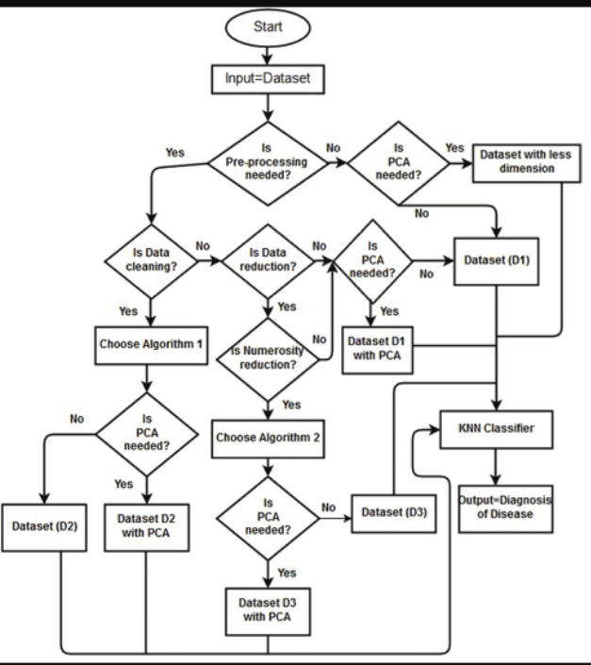

**6. RESULT**

Based on all the inputs entered by the user, the model predicts the status of the user which have two kinds of outputs yes or no depending on his/her hormonal levels and other factors.

**7. ADVANTAGES & DISADVANTAGES**

**Advantages**:

* It gives accurate output for users input as the accuracy of model is 88 percent.
* It has a very user friendly interface.
* And the results can be easily understood by the users.

**Disadvantages**:

* User should have the knowledge about his/her hormonal levels of a large number of hormones.

**8. APPLICATIONS**

* It can be used by the hospitals to monitor a patient condition and its caring levels.
* It can be used by the government to rate hospitals so that people get to know which hospital is good.
* It can be used by the patient to know whether he/she needs further medication.

**9. CONCLUSION**

As we know health is wealth. In a nut shell with this application we can predict the readmission of a diabetic patient and can have both health and wealth.

**10. FUTURE SCOPE**

In future this can be developed in such a way that it can give proper cause of readmission that is the model may predict which hormone cause readmission and in how many days the patient will readmit.

**11. BIBILOGRAPHY APPENDIX**

Model Building & Application Building